Life Insurance Beyond the Death Benefit

National Life's Living Benefits
By Steve Shorrock, ChFC, CLTC, FLMI

Life insurance products all have one thing in common: they pay the death benefit at the death of the insured. This has been the hallmark for life insurance companies since their creation over 300 years ago.

This is where the similarities stop as times are changing and as insured’s life expectancies continue to get longer, their insurance protection needs also change. Historically, life companies have based their business on providing benefits at the time of death, but innovative companies are increasingly offering ways to help insureds while they are still alive. This asset class not only pays at death, but now allows for the acceleration of your death benefit to cover the potentially devastating costs of living too long or providing lifetime income.

Life Changes. Protect It!
Consider the following:
- About every 26 seconds, an American will suffer a coronary event, and about every minute someone will die from one.
- On average, every 40 seconds someone in the US has a stroke.
- At age 65, the odds are nearly one in two that you will require nursing home services for at least 2.5 years.
The future is unpredictable and life insurance policies that permit the acceleration of the death benefit for either a chronic, critical and terminal illness provide access to benefits you can use while you are living. Accelerated benefits riders provide access to the tax-free death benefit, to help cover costs that may be associated with, or incurred due to a chronic, critical or terminal illness. These expenses might include:
- Nursing home care
- Adult day care
- Drug therapies
- Home health care
- Medical procedures
- Quality of life expenditures
Life events such as these can happen at any time and each life stage you pass through presents new needs, challenges and opportunities. With a policy that provides the ability to accelerate the death benefit, offers more than a death benefit, as it helps insure for life changes.

National Life Insurance Company has developed innovative life products and riders that help toward accomplishing objectives and conquering goals through the life changes below:
- Premature Death
- Chronic/Terminal Illness
- Critical Illness
- Lifetime Guaranteed Income

The National Life product offerings provide a series of living benefits: if you become ill, through the tax-free acceleration of the death benefit for chronic, critical and terminal illnesses, and if you live too long by tapping into policies' cash values in tax–efficient ways providing guaranteed income for life. Providing living benefits also opens the life insurance market to people without dependents that may not need the death benefit but need the living benefit aspects of the product.

These living benefits are available with the National Life's Universal Life and Term products. The Universal Life products also provide for a guaranteed income stream you cannot outlive.

National Life's Long-Term Care/Chronic Illness Acceleration:
Income tax-free living benefit in the event of a long-term/chronic illness through the Chronic Illness Accelerated Benefits Rider. Rider specs include:
- Available on all table ratings and all policies up to $2 million of death benefit
- Annual acceleration limited to the indexed IRS per diem benefit, $113,150 for 2012
- Own doctor must certify annually that insured is unable to perform 2 out of 6 ADL’s or cognitive impairment. ADL’s – Eating, Toileting, Transferring, Bathing, Dressing and Continence

- No additional premium cost.
- Rider is not underwritten separately.
- Cash Benefit, no restrictions on the use of the benefit. Do not need to be in a facility or receiving licensed home care.
- Works well in trust-owned policies.
- Paid–up policy is available at the time of acceleration.
- No waiting period to accelerate the benefit.
National Life's Critical Illness Acceleration:
Ability to accelerate the death benefit as a result of a qualifying event:
- Heart Attack, Stroke, Cancer, End Stage Renal Failure, Major Organ Transplant, ALS or Blindness.
- No additional premium cost.
- On all standard and above policies.
- Maximum lifetime payout - $1 million.

National Life's Guaranteed Income for Life Rider
The fear of outliving retirement income has become a very realistic concern to many who face retirement, and for good reason. Growing old isn’t what it used to be, and in many ways, that is a good thing. People are not only living longer, they have better educations – resulting in better health, higher income, and a higher standard of living in retirement.

But as Americans continue to live longer, a new challenge presents itself: “How do I make sure my retirement income lasts and do not outlive my retirement income?” National Life's Universal life products that have a guaranteed income for life rider, once exercised, guarantees a stream of income for the rest of your life – an income stream you cannot outlive.

National Life's products provide life insurance beyond the death benefit and have the ability to plan for life’s changes all within one policy:
- Income-tax free death benefit
- Tax-deferred build-up of cash value
- Access to the death benefit in the event of a chronic, critical or terminal illness
- Ability to receive guaranteed income for life.

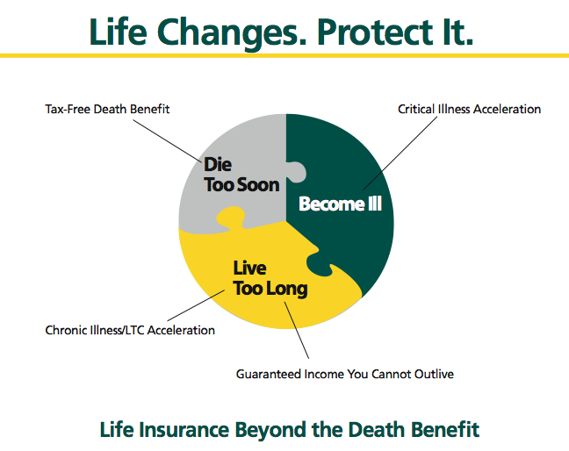

Steve Shorrock has over three decades of executive experience in life insurance, including 14 as President and CEO of Bankers Life of New York, which is now part of Aviva. He is currently President of LifeVentures Corp, which designs new life insurance products and develops marketing concepts for agents. He is also Director of Planning 4 Longevity, a firm that helps people financially plan for their entire lifetime and Director of Veris Settlement Partners, a life settlement firm that brokers seniors’ unwanted or unneeded life insurance policies. You can reach him at his Northport, Long Island office at 631-239-6655 or steve@lifeventurescorp.com

